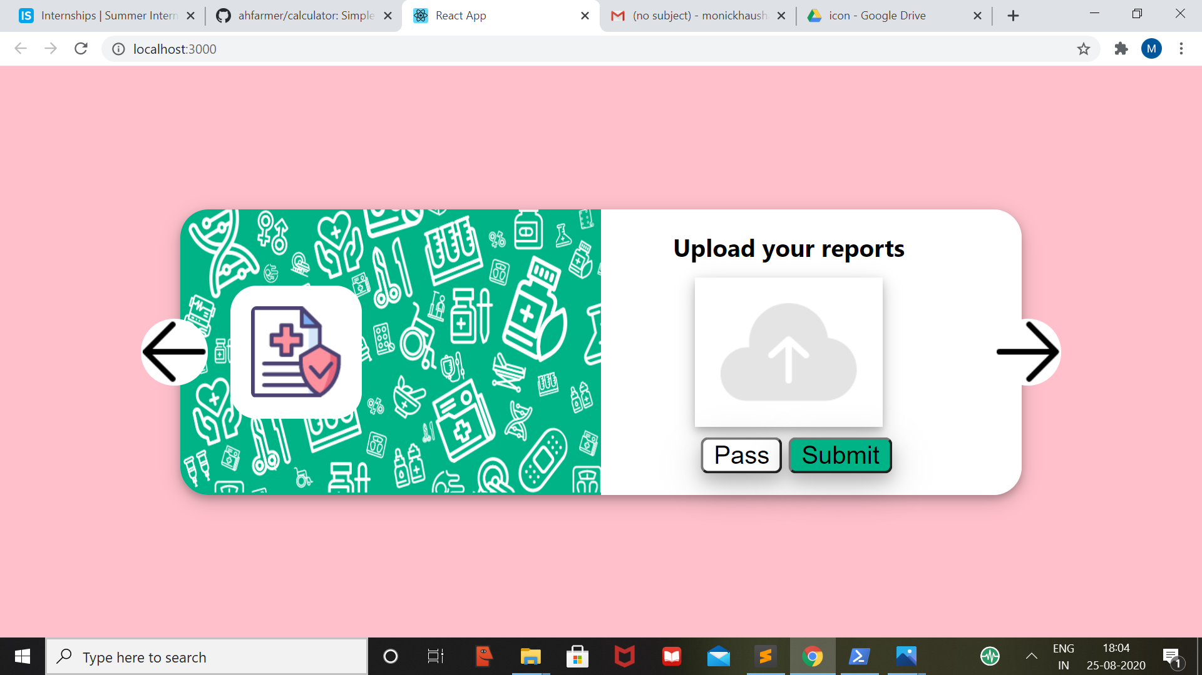**REACT SINGLE PAGE PROJECT – (SUBMITTED BY MONICKHA RAJAN)-🡪INTERNSHALA**